SUPPORT NORTH CENTRAL HIGH SCHOOL

BOYS BASKETBALL PROGRAM

Please consider sponsoring the boys’ basketball program at North Central High School through our annual banner fundraiser. Your contribution is instrumental in providing our program with team necessities. The cost for a new banner is $250, and every year thereafter the renewal rate is $250. This will secure a space for your banner in the North Central gymnasium, to be seen at athletic events and school functions throughout the 2013-2014 school year.

We would like to remind you that your contribution is donated to the program to aid in team costs such as uniforms, equipment, traveling expenses, and other miscellaneous items. Our program is mainly funded by fundraisers and corporate sponsors, so monetary donations of any amount are greatly needed and appreciated!
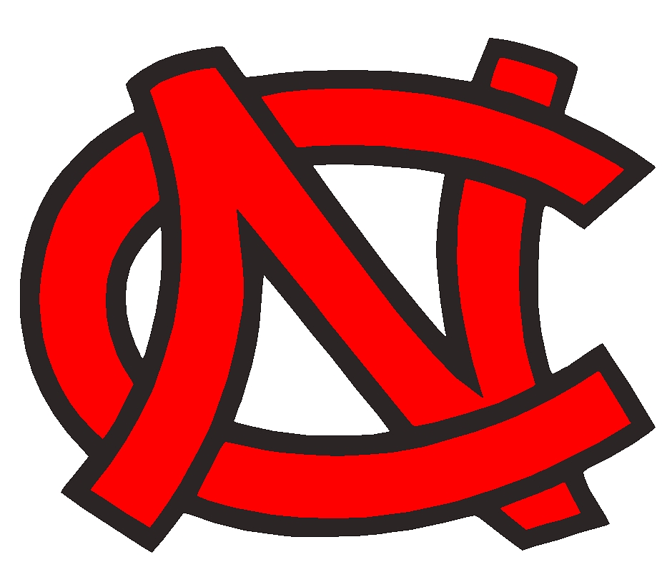
Checks should be made out to:

North Central HS Boys’ Basketball
Please remit payment and form to:
Ron Smith
8604 North Pamela Street
Spokane, WA 99208

Each banner is 2 x 5ft, with 2-color artwork. If your logo or banner requires more than two colors, an additional fee may apply. Please send your artwork via email to Ron Smith, North Central HS Basketball Parent Group Member; at ronandbeckie@gmail.com. We will follow up with a proof of your artwork before your banner is created.

If you have any questions, or need to speak with someone about your banner, please contact Ron Smith at (509) 385-8782.
------------------------------------------------------------------------------------------------------------
Please complete information below, detach and return with your payment to Ron Smith, Attn: North Central HS Boys’ Basketball.

Company Name:_____________________________________________________

Contact:_____________________________________________________________

Ph:___________________________________ Email:______________________________________

Address:_______________________________________________________________________________________________________
THANKS FOR YOUR SUPPORT!

